**Design Brief Document**

-Design objectives

I have been commissioned to create a small prototype website for a local charity called The City Farm. The prototype website should be a good representation of the finished project, but without custom content (e.g using example images and descriptions).

The website should have the option to donate, and be able to offer monthly memberships, as this is something the organisation already offers which should be integrated into the organisation website. However, The City Farm are also interested in developing new sources of income though the website, so I need to try and come up with some ideas for new income streams.

**The main goal** of this website is to generate more visitors and income, so I will keep this in mind when designing the website, making sure that donations and membership options are the focus, the additional income can then be measured by comparing online and in-store income.

**The secondary goal** is to give The City Farm an online presence, The City Farm offers a training service for vulnerable adults, therefore I believe the website should be simple and easy to navigate to keep it accessible for less-able people.

**The long-term goal** is the possibility of developing new income streams, I should leave the website open to future expansion.

-The Target Audience

The main visitors that will be using the website fit into 3 Key user groups; vulnerable adults, donators/supporters and produce shoppers.

**Vulnerable adults**

This key-group is made up of the individuals that the organisation provides services for, the main task this group will be trying to achieve through the website is event and services information, and membership details.

**Donators/supporters**

This key-group is people who want to contribute to the organisations cause by donating and/or purchasing a membership.

**Produce shopper**

This key-group is those that are trying to access the website to view available produce, produce information and shop open times.

|  |  |
| --- | --- |
| Johnathon – “Vulnerable adult | |
| Behaviours | “I look forward to social events, they help me to regain my confidence”  Johnathon is a semi-independent adult who has suffered a stroke, leading him to have difficulties talking, socialising and performing simple tasks.  Johnathon attends many events catered for vulnerable adults to give him a chance to work on his social skills and to feel comfortable and included.  Due to Johnathon’s condition he is not familiar with, and does not use much modern technology.  Key characteristics   * Age 18+ * Is socially challenged * Limited capability in performing daily tasks   Goals   * To regain social skills * To regain feeling of independence and confidence. |
| Internet usage |
| Low High  Tech savvy  Low High  Social skills  Low High |

-Persona scenario

Johnathon has heard of The City Farm’s training services from a friend and is interested in attending but does not yet know much about the charity, he googles the site and is presented with the home screen, from here he sees the banner at the top of the page with the buttons annotated ‘Home’ ‘About us’ ‘donations and memberships’ ‘Contact us’ and ‘events & services’ , from here he selects about us and reads into detail about the services on offer. After some research Johnathon decides he want to attend one of the training sessions, he selects events & services and looks at the timetable provided for the soonest one, however Johnathon is still nervous and he doesn’t do well in social settings and wishes to talk to someone about whether there will be support for those with speech difficulties before he attends, Johnathon decides to go onto the ‘contact us’ page, from there he creates an email using the email form provided on the ‘contact us page’.

-Personality and Tone

Website Design sketches

|  |  |  |
| --- | --- | --- |
| Home | About us | Contact us |
|  | C:\Users\14732394.UNI.000\AppData\Local\Microsoft\Windows\INetCache\Content.Word\About us.jpeg | C:\Users\14732394.UNI.000\AppData\Local\Microsoft\Windows\INetCache\Content.Word\Contact us.jpeg |

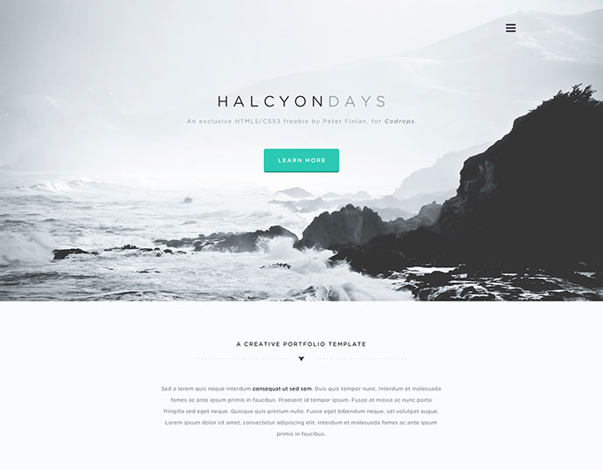Desired mood

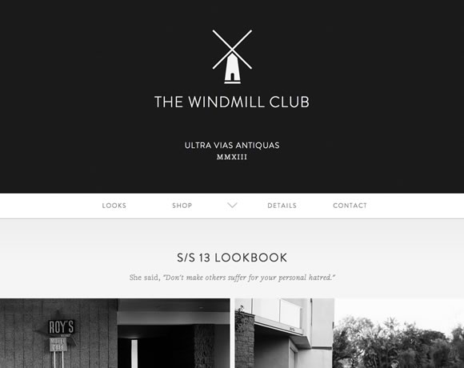

|  |
| --- |
| [Exam](http://at-web2.comp.glam.ac.uk/students/14732394/index.htm)ple Header |
| Example header |
| Example text |

|  |
| --- |
|  |
|  |

Persuasive tactics

As producing more income is the main goal of the website for City farm, I have made sure to put emphasis on the structure of the donations and membership’s page, donations and memberships are within the same form, so that anyone who wanted to either donate or become a member gets to consider both. Increasing potential income.

Single minded message

**simplicity**

I believe that “simplicity” sums up the design quite nicely, I wanted a website that wasn’t crowded, felt like it had a good simple common structure and had an easy on the eye theme.

**PHP code listing**

|  |
| --- |
| <!DOCTYPE html>  <html dir="ltr" lang="en">  <head>  <title>Donations & memberships</title>  <meta charset="UTF-8">  <link href="CityFarmStyle.css" rel="stylesheet" type="text/css">  </head>  <body>  <div class="wrapper row1">  <header class="clear" id="header">  <div id="logo">  <h1><a href="http://at-web2.comp.glam.ac.uk/students/14732394/index.htm">City Farm</a></h1>  <h2>Lifestyle services and produce</h2>  </div>  <nav>  <ul>  <li>  <a href="http://at-web2.comp.glam.ac.uk/students/14732394/index.htm">Home</a>  </li>  <li>  <a href="http://at-web2.comp.glam.ac.uk/students/14732394/about.htm">About us</a>  </li>  <li>  <a href="http://at-web2.comp.glam.ac.uk/students/14732394/cafe.htm">Cafe & Produce shop</a>  </li>  <li>  <a href="http://at-web2.comp.glam.ac.uk/students/14732394/donate.php">●Donations & Memberships●</a>  </li>  <li class="last">  <a href="http://at-web2.comp.glam.ac.uk/students/14732394/contact.htm">Contact us</a>  </li>  </ul>  </nav>  </header>  </div>  <!-- end of header -->  <div class="wrapper row2">  <div class="clear" id="container">  <div id="full">  <img id="gif" src="images/friends.png" alt="images/friends.jpg">  <h3>How your donation helps us</h3>  <p class="Main">  The City Farm is a local charity which runs a small farm. The City Farm provides training opportunities  for vulnerable adults, allowing them to develop skills and social confidence.  The City Farm is open to visitors and has a small café.  City Farm is entirely self-funded. <br>  Lorem Ipsum is simply dummy text of the printing and typesetting industry. Lorem Ipsum has been the  industry's standard dummy text ever since the 1500s, when an unknown printer took a galley of type  and scrambled it to make a type specimen book. It has survived not only five centuries, but also the  leap into electronic typesetting, remaining essentially unchanged.<br><br> </p>  <div>  <p><form>  <fieldset>  <legend>Account</legend>  <p><label for="Name">Name*: </label><input id="Name" Name="Name" type="text" maxlength="50" required></p>  <p><label for="Email">Email*: </label><input id="Email" name="Email" type="text" maxlength="50" required></p>  <p><label for="Password">Password*: </label><input id="Password" name="Password" type="text" maxlength="50" required></p>  </fieldset>  <fieldset>  <legend>Donation</legend>  <p><label for="Donation">Donation*: </label><input id="Donation" name="Donation" type="text" maxlength="8" value="£" required></p>  </fieldset>  <fieldset>  <legend>Membership</legend>  <?php  include("dbinfo.inc.php");  $conn = mysqli_connect($servername, $username, $password, $database);  // Check connection  if (!$conn) {  die("Connection failed: " . mysqli_connect_error());  }  ?>  <?php  $sql="SELECT * FROM membership ORDER BY membership";  $result = $conn->query($sql);  ?>  <table class="memberships">  <caption>Membership prices</caption>  <thead>  <tr>  <td><strong>Membership</strong></td>  <td><strong>One month</strong></td>  <td><strong>Three Months</strong></td>  <td><strong>One Year</strong></td>  </tr>  </thead>  <tbody>  <?php  if ($result->num_rows > 0) {  // output data of each row  while($row = $result->fetch_assoc()) {  echo ("<tr>\n");  echo ("<td>".$row["membership"]."</td>");  echo ("<td>".$row["one month"]."</td>");  echo ("<td>".$row["three months"]."</td>");  echo ("<td>".$row["one year"]."</td>");  echo ("</tr>\n");  }  } else {  echo "0 results";  }  ?>  </tbody>  </table >  <div>  <p><br></p>  <input type="radio" name="membership" id="memgold"  value="gold" checked><label for="memgold">Gold</label>  <input type="radio" name="membership" id="memplat"  value="plat" checked><label for="memplat"> Platinum</label>  <input type="radio" name="membership" id="memsilver"  value="silver"><label for="memsilver"> Silver</label>  <input class ="submit" type="submit" value="Submit">  <input type="reset" value="Clear">  </fieldset>  </div>  </div>  </div>  </div>  <!-- Footer -->  <div>  <footer class="clear" id="footer">  <p class="fl_right">Copyright © 2018 example legal info</p>  </footer>  </div>  </body>  </html> |

**Media Sources**

|  |  |
| --- | --- |
| media | source |
|  | http://www.ldcarerscommunity.org.uk/home__trashed/group-of-happy-people-with-disabilities/ |
|  | https://garfieldconservatory.org/event/goat-visits-7/2018-07-27/ |
|  | http://www.farmtofactory.org/ |
|  | https://www.beyondblue.org.au/who-does-it-affect/older-people/have-the-conversation-with-older-people |
|  | https://www.coventrytelegraph.net/whats-on/shopping/aldi-giant-strawberries-wimbledon-14758209 |
|  | https://www.heeleyfarm.org.uk/page/visiting |
|  | http://www.hotelroomsearch.net/united-kingdom/old-farm |
| Image result for carer staff | http://news.oxfordshire.gov.uk/being-a-wellbeing-team-carer-is-so-wonderful--we-just-love-our-jobs/ |
| Farm stock footage | https://www.youtube.com/embed/dJxpdesftcg |
| Image result for small farm cafe photo | http://www.thegedituk.com/2017/03/farm-girl-cafe-london.html |
| Image result for produce stall indoors | https://www.flickr.com/photos/rossendalewadey/2570945244 |
|  | https://themighty.com/2017/05/having-friends-with-cerebral-palsy/ |

Validation reports

|  |
| --- |
| Home/Index |
| About |
| Café and produce |
| Donations and memberships (php)    (I had difficulty finding the stray elements as they weren’t where the validator reported) |
| Contact us |

**CSS evaluation**

Within my .css I used multiple containers, ID’s, classes overrides. I divided my code into multiple sections to make it easier to understand the layout, one of the largest sections I called building blocks, as most of the code is used multiple times for common formatting, hence im using them as building blocks.

One important aspect of my styling is my use of wrappers, it essentially displays a block which I can change the colour of to create the websites banner nav area.

* **div.wrapper** – applied to <div> to create nav bar and banner
* **.row1 .row2** – simplecolour class for the nav bar and banner

I also made use of lots of containers, these were very useful in formatting the layout of the webpages, I used 4 different containers just for holding text

* **#full** – creates a text container the full width of page
* **#fullB** – same as full but has a margin on bottom to separate content from next <div>
* **#half** – creates a text container half the page width
* **#twothirds** – self explanatory, good for text with images.

Containers were used heavily throughout my design as I found them very useful for adding padding to any entity by placing it into a container first.

I used classes for multiple font formats **.Main** was the primary text format, **.MainR** is the same format but text is aligned to the right.

I created 5 classes for positioning;

* **.imgl .imgr** – positions image left/right with some padding.
* **.fl_right .fl_left** – floats item left/right.
* **.lastbox** – removes right margin from last nav button.

**Self evaluation**

I am quite happy with the outcome of the website, I spent a while on the project learning how to format text and images to co-operate within CSS, with the use of containers, and classes using margins, borders and float.

I really like the colour theme of the website, it uses all blues, with darker blues on the banner and header and other entities to highlight them.

I’m happy with the layout of the website although I would have liked to format the forms and tables better, I did also want to learn how to create an image slider, I went with the easier option of creating a GIF.

If I were to design this website again, id try to make a better banner without using the clear function.